Supplementary Material
Nanoencapsulation of saffron (Crocus sativus L) extract in zein nanofibers and their application for the preservation of sea bass fillets
Zahra Najafi^{a*}, Turgay Cetinkaya^{a,b}, Fatih Bildikª, Filiz Altayª, Neşe Şahin Yeşilçubukª
ª Department of Food Engineering, Faculty of Chemical and Metallurgical Engineering, Istanbul Technical University, 34467, Maslak, Istanbul, Turkey
^{b} Food Processing Department, Armutlu Vocational School, Yalova University, 77500, Yalova, Turkey

*Corresponding Author
Zahra Najafi, Fax : +90-212-285-7333
E-mail : najafi@itu.edu.tr

List of Contents
Content
Table S1 3
Figure S1 4
Figure S2 5
ABTS method 6
TVBN method 7
TBARS method 8
Figure S3 8
PV and FFA methods 9
Figure S4 10

Table S1. Effect of zein concentration, addition of SE and applied voltage on mean fiber diameter of electrospun nanofibers.
Fiber | Zein % (w/v)* | SE % (w/w)** | Applied voltage  (6 kV) | Applied voltage  (14 kV) | Morphology
ZN | 15 | 0 | 83ª±21 | - | Droplets with very rare fibers at a voltage of 6 kV
ZN | 25 | 0 | 297^{b}±90 | - | Beaded at a voltage of 6kV
ZN | 30 | 0 | 369^{c}±166 | 429ª±181 | Beadless at both voltages
ZNLSE | 30 | 5 | 388^{c}±147 | 450ª±137 | Beadless at both voltages
ZNLSE | 30 | 10 | 440^{d}±136 | 544^{b}±197 | Beadless at both voltages
Data are displayed in means ± standard deviation of at least one hundred replications. Values in each column with different letters were statistically significant (p<0.05).
* With respect to solvent (ethanol/water, 8:2)
**With respect to zein polymer

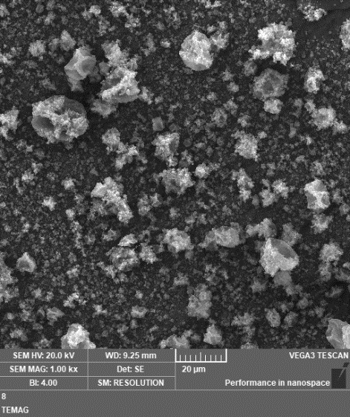
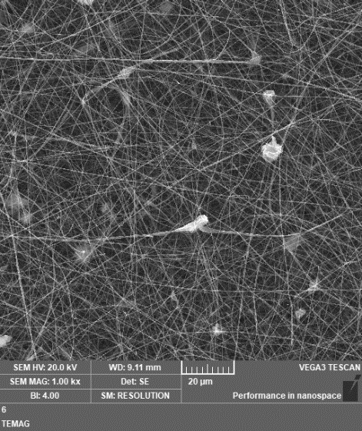
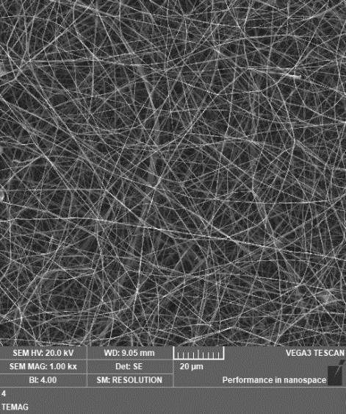

a)

(c)
(b)
(a)
Fig. S1. Morphology of electrosprayed and electrospun zein obtained from a) 15% (w/v), b) 25% (w/v) and c) 30% (w/v) polymer solutions at a voltage of 6 kV. Magnification is 1000×

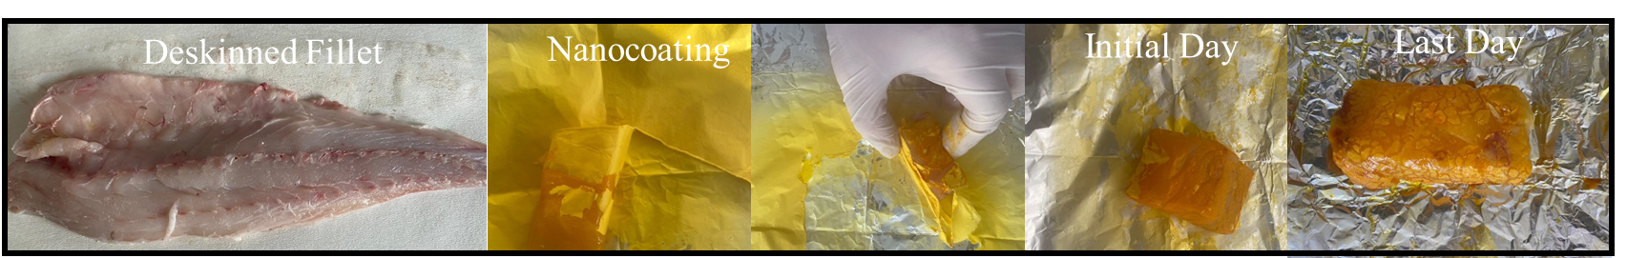

Fig.S2. Coating of sea bass fillets with ZNLSE (10% SE)

ABTS Method

Diluted ABTṠ⁺ solution (with absorbance of 0.7 at 734 nm) was mixed vigorously with 0.1 mL of the prepared solution. The AA was calculated based on reduction of absorbance of the ABTS⁺ solution after standing 6 min at 734 nm according to the following equation.
$\% AA =\frac{{( A_{0}- A_{1})}_{ }}{A_{0}}×100$
where A₀ is absorbance of control (without sample) and A₁ is the absorbance of the sample.

TVBN method
Ten grams of fish fillets were homogenized using Ultra-Turrax (IKA T18, Germany) in 50 mL distilled water. Samples were located into three parallel extraction flasks and mixed with MgO and 200 mL distilled water. Then, the mixture was distilled for 20 min after 10 minutes of boiling. The bases were collected in small round bottom flasks including 100 mL distilled water, 10 mL 0.1N HCl and tashiro indicator. Finally, the distillate in small flasks was titrated with 0.1N NaOH. The TVBN values were calculated according to the valume of 0.1N NaOH was used during titration. The TVBN amounts in sea bass fillets coated with ZNLSE and control samples were calculated as mg/100 g flesh using the following formula:
TVBN (mg/100 g sample) = $\frac{(V_{1}-V_{0})×0.14×2×100}{M}$
Where: V₁ is the valume of titration of sample (ml of 0.1 N NaOH), V₀ is valume of titration of control (withiout sample), M: Weight of fish sample (10 g)

TBARS method
Ten grams of homogenized fish samples was placed into three parallel of 500 ml round bottom flasks, then the distillated water and 2.5 mL (4N HCl) were added. After boiling and distillation, 5 mL of distillate was poured into the falcon tubes and 5 mL of 0.02 M TBA reagent was inserted. Tubes were hold in boiling water (100 °C) for 35 min. After cooling, the absorbance values of the pink solution was assessed at 532 nm using spectrophometer (SP-3000 plus, OPTIMA INC. Japan). The TBA values of the samples were expressed as mg malondialdehyde per kg of fish. The constant 6.2 was used to calculate the TBARS value using Eq. 7 (Crackel et al., 1988).
TBARS value = 6.2 Abs₅₃₂
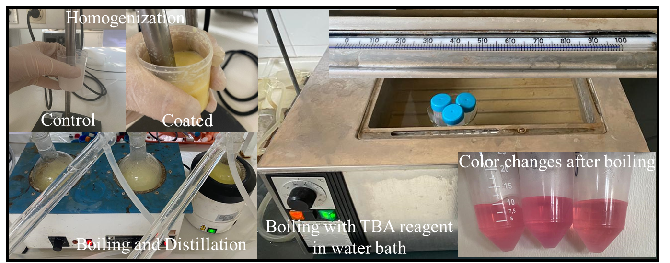
Fig.S3. Photographic images of TBARS analysis stages

PV and FFA analysis
Chloroform (100 mL) was added to 20 g of fish samples, after homogenizing and filtration, 20 mL of water was added to filterate. Then the mixture was decanted and chloroform phase was collected. Finally, 1 g of Na₂SO₄ was added to this phase and it was filtered. The chloroform phase was used for PV and FFA analysis.
The determination of total free fatty acids was done by titration of 10 mL of the lipid extract dissolved in 20 mL of ethanol/diethyl-ether (1:1), with an ethanolic solution of 0.1N KOH, using phenolphalein as indicator. Free fatty acid content was expressed as g of oleic acid/100 g of fish sample. FFA was calculated according to the following equation:
FFA %= $\frac{Titration \left(A-B\right)×n×282×100×dilution factor}{1000 ×W }$

A= number of ml of KOH titrated with fat of oil
n= normality of KOH
sample B= number of ml KOH titrated with blank sample
282=Oleic acid molecular weight
W: weight of sample (20 g)
The peroxide value analysis was performed as following: 30 mL of glacial acetic acid and 1 mL of a saturated solution of KI were added to 20 mL of the lipid extract. The mixture was then agitated gently and kept in the dark for 5 min. It was then titrated with 0.004 M Na₂S₂O₇, using starch as indicator. The peroxide value was expresed as meq of oxygen/kg of fish sample.
PV (meq oxygen/kg of fish sample): $\frac{V ×n×1000×dilution factor}{W }$
V= ml of Na₂S₃O₄ used in titration
n= normality of Na₂S₂O₇
W: weight of sample (20 g)

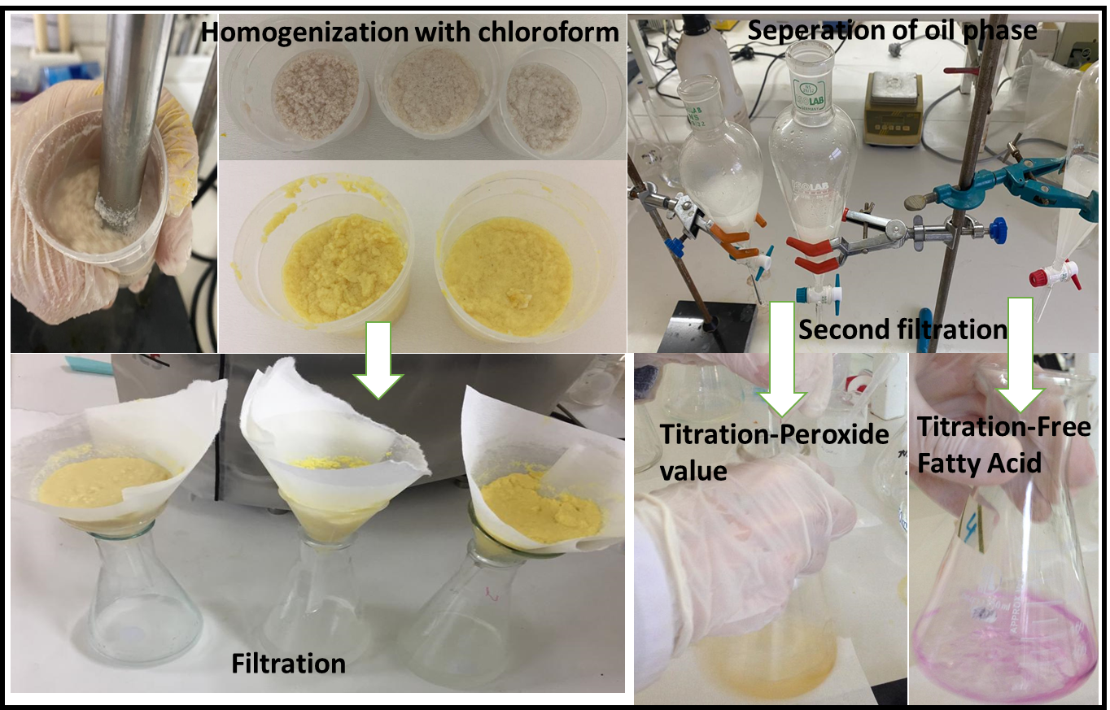

Fig.S4. Photographic images of peroxide value and free fatty acid analysis

